Discussing injuries and concussion at OUABC
OUABC have collected information to aid you in the event of an injury during your time at the club. Whilst all sports pose risks to those involved, listed below are risks we believe to be more relevant to boxing specifically.
Before discussing any specifics, there’s plenty of good practices you can bear in mind to PREVENT injuries both mild and severe:
- If you have an existing injury or concern, talk to your coach or committee in advance of training
- Ensure you get enough sleep prior to any session. Current evidence supports the notion that insufficient sleep is associated with a higher risk of sustaining a sport-related concussion.
- Eat before training (ideally not immediately before) to ensure you have enough energy to perform at your best (and most sensible).
- Stay hydrated before, during and after training.
- Avoid alcohol before sparring (including the evening before morning training) - do not spar if you are hungover or severely dehydrated.
- Do not spar if you suspect you have suffered a head injury (however minor) prior to sparring, e.g. during another sports match or on a night out.
- In the lead up to competitions, make sure you are protecting your overall health - avoid alcohol, get plenty of sleep and eat nutritionally rich food.
- Work on preventative strength training - neck strengthening exercises will reduce your susceptibility to concussion. Strengthening areas of weakness, e.g. wrists and hip flexors, can prevent injuries in the long term. Speak to the Blues Gym coaches for advice on exercises.

If in doubt, sit it out

In the case you do sustain an injury during training, we have a well-thought-out protocol and trained individuals who are able to help you through any problems you may be faced with. You do not have to handle this on your own.

Injury and/or concussion protocol at Iffley Sport Centre
- Identifying that you are injured:
  - The coach might notice a particular blow/knock/movement that raises concern. Someone watching could also notice this, during sparring and other parts of training
  - You feel that you have been injured (anything from muscular pain to headache)
- Reporting to an OUABC member:
  - Report this to one of the coaches, whichever you are most comfortable with
  - OR report this to one of the captains
  - OR report this to a Welfare Officer, or ask anyone on the team your comfortable with to mention your injury to a coach/captain
- Signifying Iffley reception staff:
  - There is ALWAYS someone at reception with 1st aid training, who can help assessing the injury (This is an important step as Iffley staff will keep track of injuries). Go to the reception desk, someone from OUABC will accompany you to reception, and the Iffley reception will reach out to the Iffley medical team.
  - Iffley staff have a partnership with a local taxi company, and they will call a taxi FREE OF CHARGE to take you to A&E (Accident and Emergency) at the JR Hospital. Someone from OUABC will accompany you.
- Signifying other important points of contact:
  - In case of any injury, OUABC will let your college know, and ensure that someone can bring you anything you need
  - We then refer back to Iffley Sport Centre and to OUABC Welfare officers to notify that you will need follow-up and formalize a risk assessment

What happens if you’re injured during an external event?
During external events (BUCS, Varsity, Town v Gown etc.), OUABC uses other venues (Chaplaincy, Union, Town Hall). There will ALWAYS be medics onsite, who will conduct their professional risk assessment. Here also, anyone you’re comfortable with from OUABC will stay with you. During these events, the OUABC doctor will also be present.
If you have to be taken to A&E, we will ensure that your college is made aware of this, and that anyone you need will be contacted.
Even if you’re not injured, your safety and security is our first concern. As such, know that our medics present during bouts fill in a T10 form on Medical Care of a Boxer After a Contest.

Focus on identifying a suspected concussion
The symptoms of a concussion can often be mild and difficult to spot, and no one wants that to impact your mental health, your studies, or overall lifestyle. Therefore, it is important to be aware of the following symptoms, as you may feel unwell and NEED some rest to prevent a mild concussion from becoming a serious concussion.
Symptoms to be aware of:
- Headache - Irritability - Dizziness - Anxiety - Nausea - Feeling depressed or tearful - Unsteadiness - Difficulty concentrating - Restlessness - Poor attention - Slowed reactions - Sleep disturbance - Memory problems - Low energy - “Feeling in a fog” - Sensitivity to light or noise

And remember, if in doubt, sit it out

Returning to sports after concussion
Below are some guidelines for returning to boxing after a concussion. As general guidance, it’s a great idea to have these in mind at the beginning of the season so that everyone training remains informed about the risks posed to boxers. When these symptoms appear, or when you’ve been officially medicalled for mild/severe concussion, you should follow these recommendations.

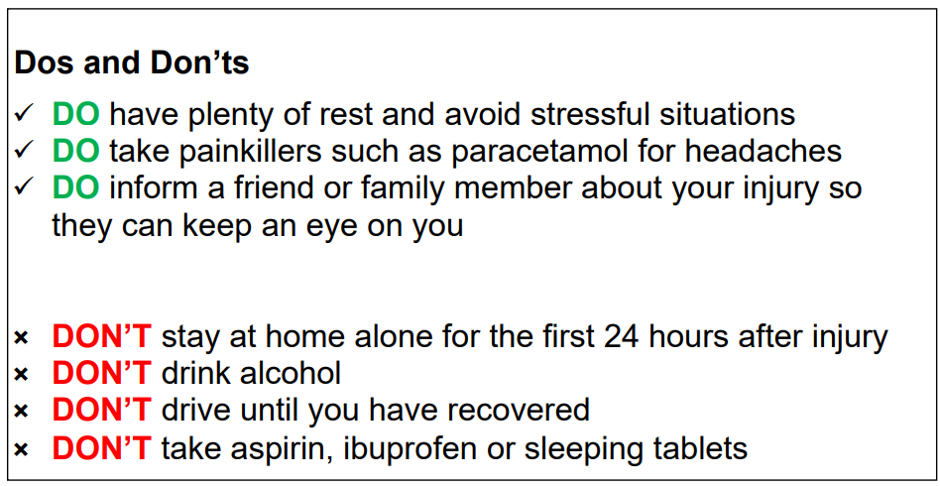
If you are found to have a mild/severe concussion, there’s an easy protocol that all OUABC committee members follow so that in the event of an injury, we can help keep track of what stage you’re at and make sure to check in regularly. Following these steps may help to prevent serious injury, even if you are not certain you have a concussion.
There’s no benefit in rushing your return to sports, and what’s most important is to take it easy, and keep the committee informed of your condition (you can find this protocol in the England Boxing Handbook referenced in the next section). This way you will ensure you do not harm yourself in a more severe way.
DO NOT RUSH THIS Taking this protocol seriously early on may feel frustrating, but not doing so could stop you from returning to sports for much longer or result in debilitating post-concussion syndrome.
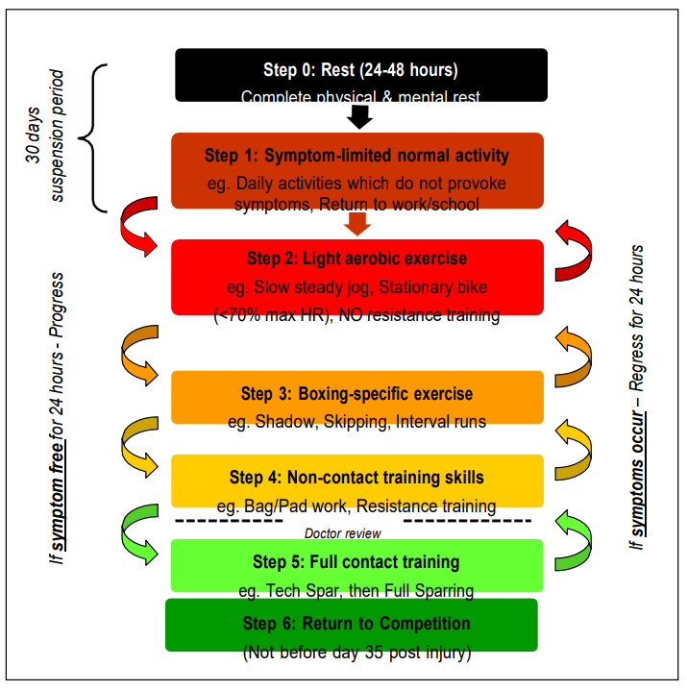

How can you report an injury?
In the event of any injury, you MUST fill in this form, or have someone from OUABC fill out the form for you. It’s VERY important that this is done so that we can follow up on anything you may need. This file goes to the Sports safety officer, who will be in charge with updating the club on details of your injury.

How can you report a complaint?
There may be a case where you wish to raise a complaint, be this following an injury or not. At any rate, talk to your COMMITTEE if in doubt, that’s what they’re there for. It’s important you know that all complaints are dealt with anonymously and confidentially with the minimal necessary people on the committee being informed about details of your complaint. Any action taken by the club will be on the advice of the Sports Federation and with your consent.
As a first step, you should email the Sports Fed (sportsfed@sport.ox.ac.uk ) with details of your complaint.
As a second step, you may wish to reach out to the Student Resolution Services (mediation@admin.ox.ac.uk ) who will act as mediators in the issue you raise.
For any smaller issues you have with the club, feel free to reach out to the Welfare Officer who will be more than willing to listen to any problems you have, and pass on the information at your discretion to the relevant parties who may be able to help with your problem (once again this process will operate on a need-to-know basis involving as few people as necessary, with all problems remaining anonymous). You can find both the Telephone number and email address of the Club Welfare officer on the website.
The clubs full Complaints Procedure can be found here.

Eating disorders in boxing
As a sport with weight categories, boxing can be particularly challenging for people who struggle with disordered eating. In order to prevent experiences that may be triggering (for example, being asked your weight, participating in a weigh-in or discussing diet), it is important you are able to speak to someone you trust in the club. They will then relay to the head coach in confidence that weight is not something you wish to discuss. You may also wish to speak to a coach directly instead. Doing so will allow the coaches to help you have a more supportive experience of boxing, and one that keeps you safe both physically AND mentally.
If you find that the process of weight management ahead of competitions is badly affecting your relationship with food or your body image, do reach out to a member of the club or committee that you trust.

Weight cutting in boxing
As mentioned above, weight cutting can be a dangerous task, and if done incorrectly can cause serious mental and physical damage. Therefore, it is important to OUABC that everyone undergoing weight cutting does so following the England Boxing Weight management Guidance.
Please also see the Club Policy regarding weight cutting.
If you are struggling with weight cuts, it is important that you reach out to someone on the committee you trust who can help you with the process and guide you to the relevant people/resources required.
For help undergoing a weight cut, please follow the guidance attached above from England Boxing, and also feel free to ask the captains and other club members who have cut weight before for their advice as well (but understand their advice is NOT professional advice and should NOT be supplemented for well researched information from reputable sources such as those listed above and below). Please also consult the Welfare office for the club who will have various resources available on healthy weight cutting for boxing specifically and information on who best to talk to for more detailed advice.
Individuals undergoing weight cuts for bouts will also have a weekly meeting from the start of the weight cutting process (defined as 2-3 weeks prior to a bout by England Boxing) with the club Welfare officer, up to their fight just to check on their progress and ensure it meets club/England Boxing guidelines and requirements for their bout. This ensures no one is cutting unhealthy amounts of weight in a short period of time. It is also a chance to check on how the person is doing mentally, as anyone who has undergone a weight cut will know that it can be a mentally demanding time.
Once again, you do NOT need to cut weight if you do not feel comfortable doing so. This does not inhibit your ability to compete for OUABC.

Resources for boxers

Eating disorder charities:
- BEAT: https://www.beateatingdisorders.org.uk/
- National Centre for Eating Disorders: https://eating-disorders.org.uk/
Eating disorder screening questionnaire: https://screening.mhanational.org/screening-tools/eating-disorder/

Advice on weight loss for athletes:
- Weight Management for Athletes and Active Individuals: A Brief Review (Manore, 2015) https://www.ncbi.nlm.nih.gov/pmc/articles/PMC4672016/
- Healthline Article on Sciende-Based Ways for Athletes to Lose Weight: https://www.healthline.com/nutrition/9-weight-loss-tips-for-athletes#TOC_TITLE_HDR_11
- Gatorade Sports Science Institute Article on Weight Management for Athletes and Active Individuals: https://www.gssiweb.org/sports-science-exchange/article/weight-management-for-athletes-and-active-individuals/
- Weight Loss Advice from GB Boxing: https://www.gbboxing.org.uk/resources-for-boxers/eating-to-your-weight-goal/

Other resources
- Points of contact in OUABC
- Committee members (see website for contact details of individual members)
- Information on identifying concussion and injuries
- Head case, England Rugby Federation
- England Boxing Rulebook, England Boxing Federation

- Other points of contact (you can find these on the Welfare section of Oxford University Sports)
  - Sports Fed (sportsfed@sport.ox.ac.uk)
  - University Counselling Services (01865 270300, counselling@admin.ox.ac.uk, 3 Worcester Street, OX1 2BX)
  - College Staff: Nurses, Welfare officers, Junior Deans (this is college specific so check your college website)
  - Nightline: (01865 270270)
  - Disability Advisory Service: (01865 280459, disability@admin.ox.ac.uk, 3 Worcester Street, OX1 2BX)
  - Student Union VP Welfare and Equal Opportunities: (vpweo@oxfordsu.ox.ac.uk)
  - Oxford University Sexual Harassment and Violence Support Service
  - Sexual Assault Referral Centres (SARCS)
  - Harassment Advisory Network (01865 270760, harassment.line@admin.ox.ac.uk)
  - Rainbow Peers (rainbowpeers@admin.ox.ac.uk)
  - Peers of Colour (peersofcolour@admin.ox.ac.uk)
  - Oxford Sexual Abuse and Rape Crisis Centre (0800 783 6294)
  - Beat (0808 801 0677)
  - Talking Space Plus

